Macintosh HD:Users:svarvaro:Desktop:jrderbyphotosanddocs:CCJRD-RGB-1Color.eps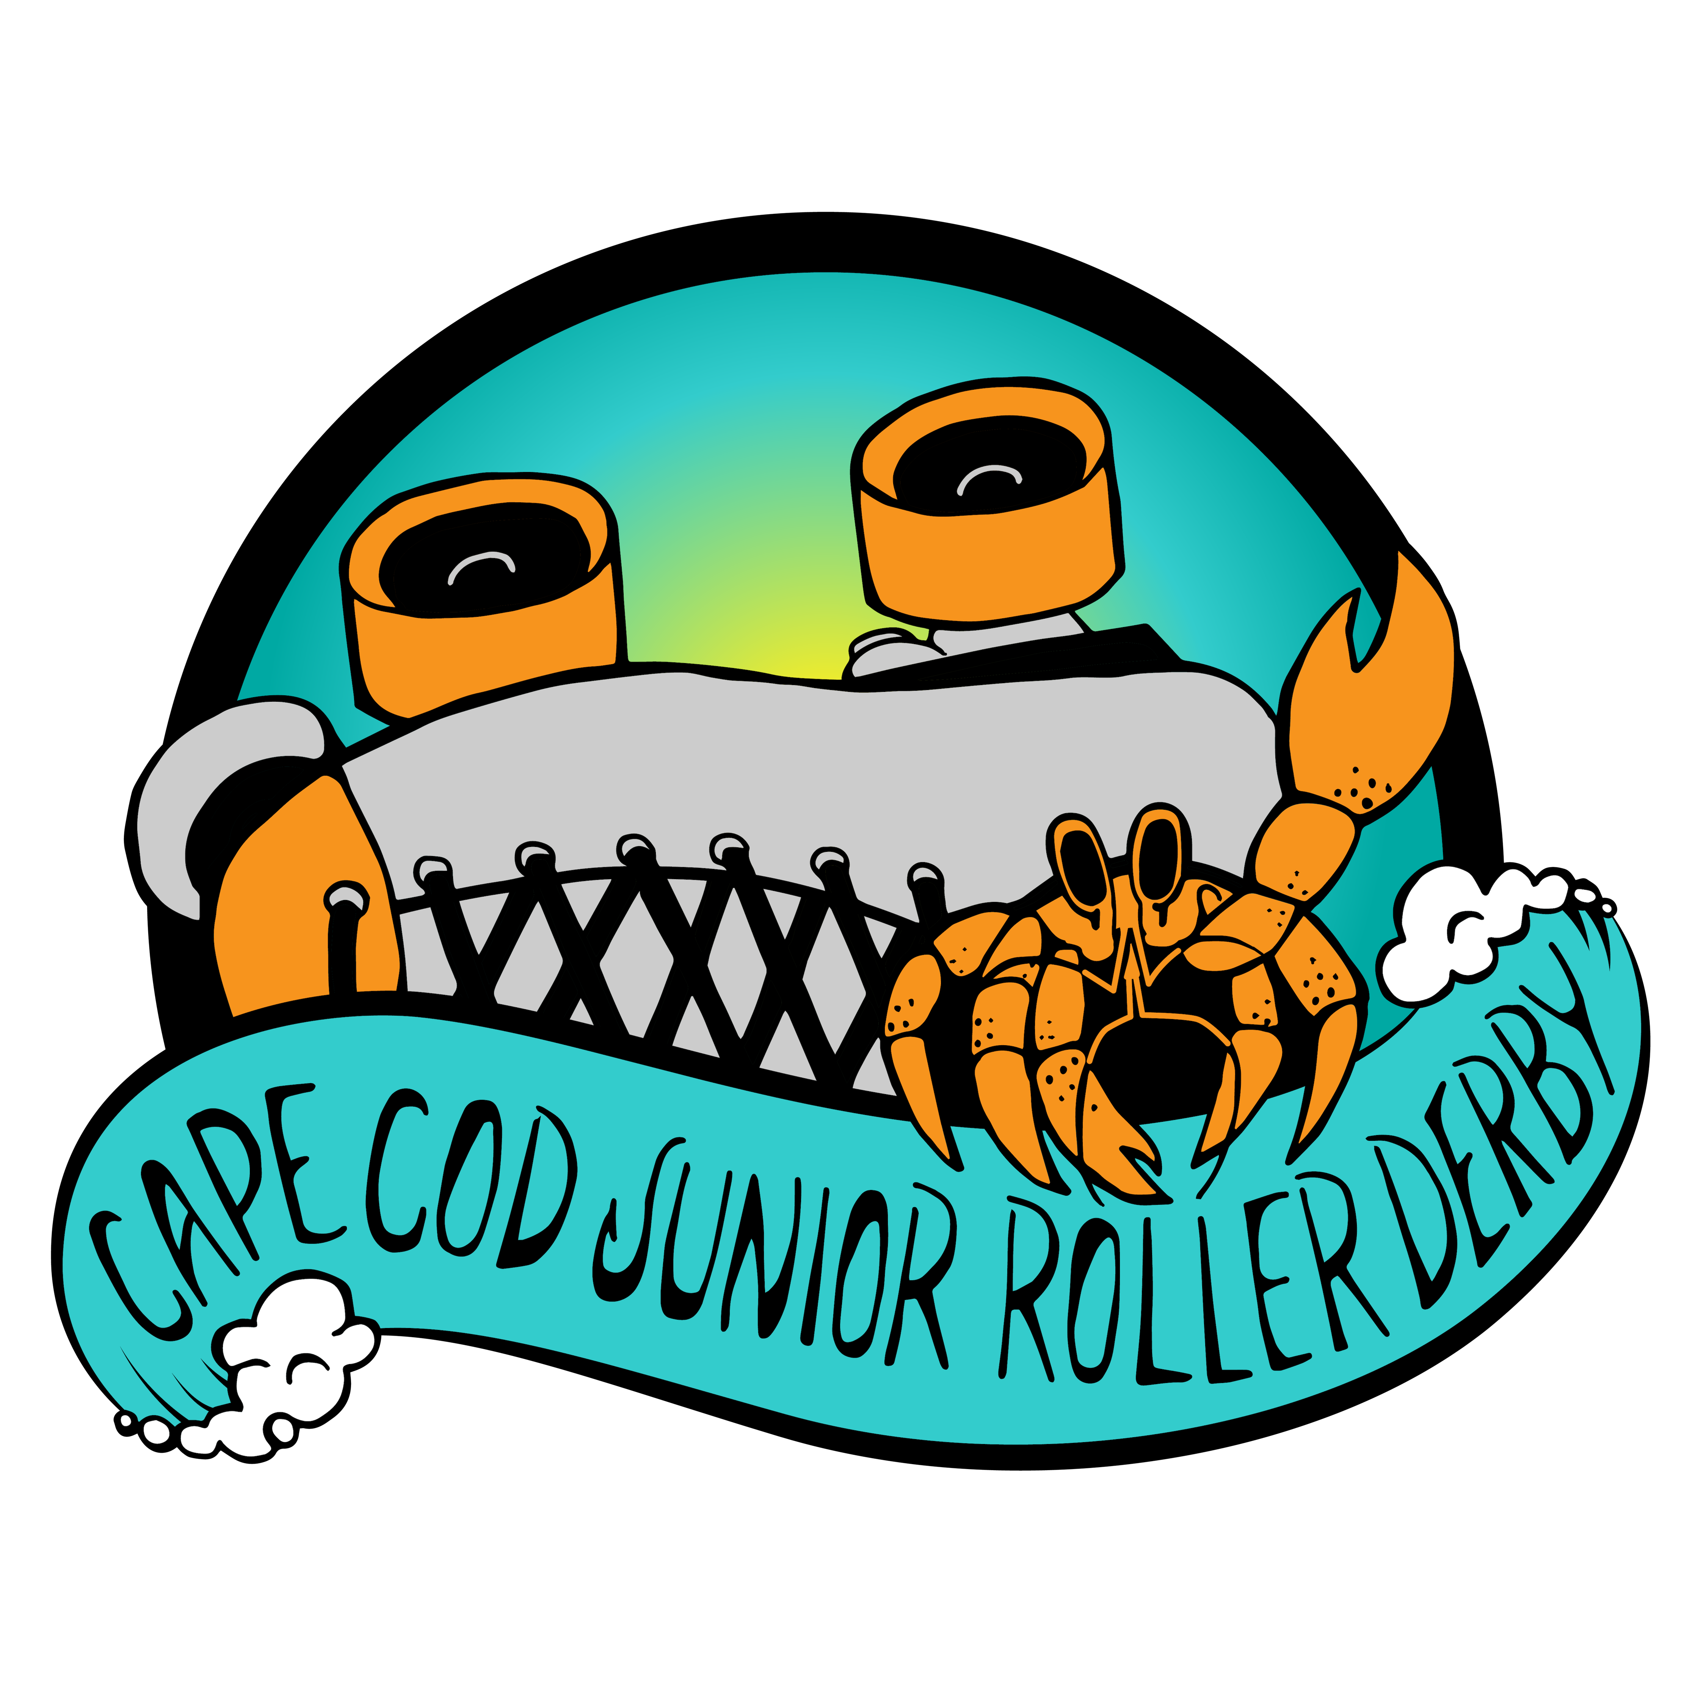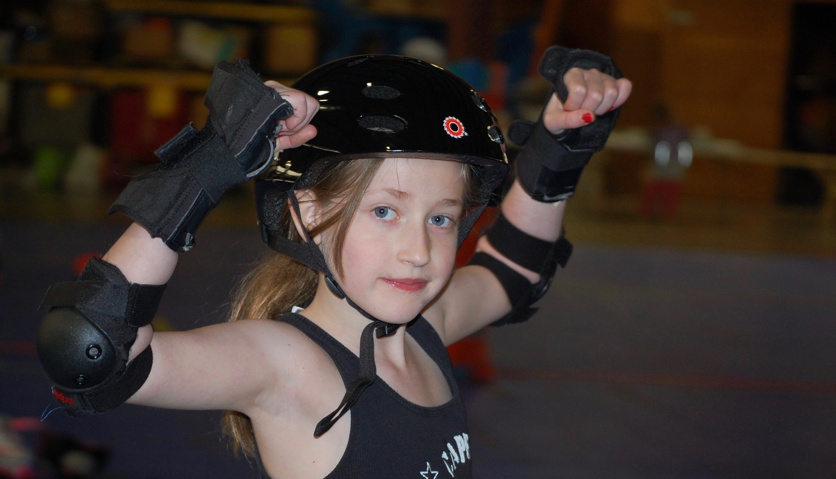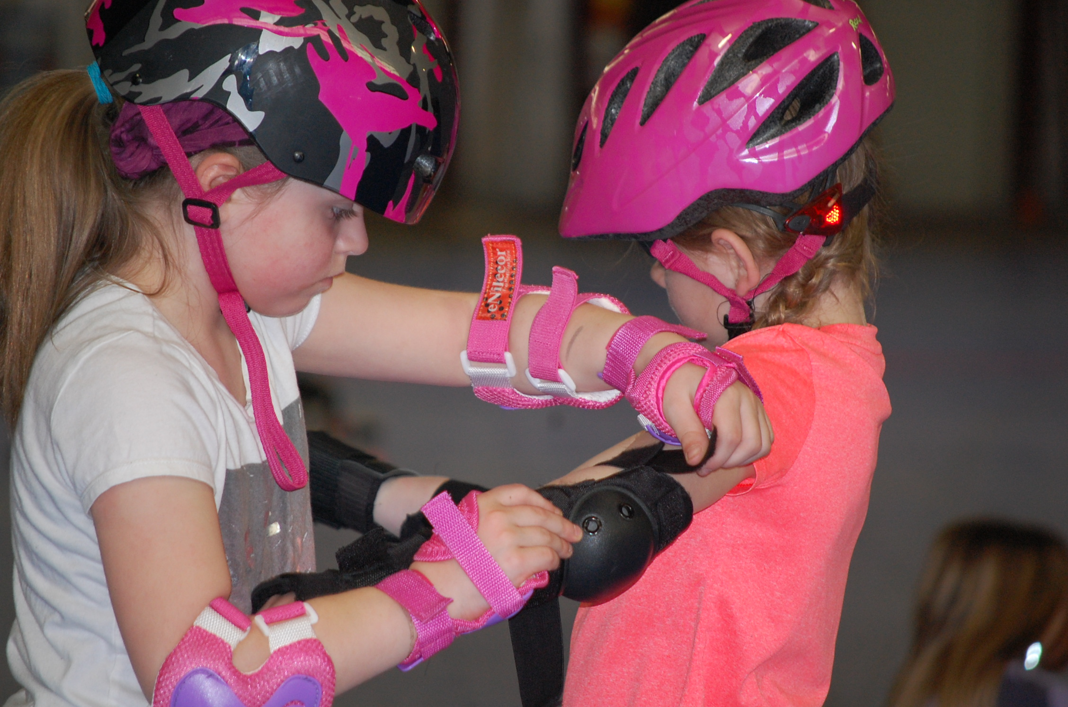

## There are many ways you can support us

* Donate to support new skaters and the purchase of loner gear for our Rental Program
* Become a media sponsor. All media we produce (i.e. websites, instagram, facebook) will showcase your support
* Become one of the first physical sponsors and get a free t-shirt! We will place your logo on our first edition CCJRD merchandise

**CONTACT   
INFO**

[Sk8teforkids@gmail.com](mailto:Sk8teforkids@gmail.com)

[www.capecodjuniorrollerderby.com](http://www.capecodjuniorrollerderby.com)

https://www.facebook.com/ccjrd

https://www.instagram.com/capecodjuniorroller/

The Cape Cod Junior Roller Derby (CCJRD) is a 501(c)(3) non-profit flat track derby program. It is open to all youth age 6 - 17. These youth represent the future of Roller Derby worldwide. We are proud to present Junior Roller Derby and help develop the next generation of roller derby athletes!

CCJRD will encourage and enrich children and teenagers in developing character, confidence, leadership, and social skills. CCJRD will also develop the athletic skills of its participants through fine tuning athletic abilities and/or discovering latent skills.

# HOW CAN YOU SUPPORT US?

Sponsorship Information

Contact Us Today!

[Sk8teforkids@gmail.com](mailto:Sk8teforkids@gmail.com)

[www.capecodjuniorrollerderby.com](http://www.capecodjuniorrollerderby.com)

https://www.facebook.com/ccjrd

https://www.instagram.com/capecodjuniorroller/

Merchandise Program:

Want to help a skater get started! You can donate towards rental gear to support their journey.

Paypal: [sk8teforkids@gmail.com](mailto:sk8teforkids@gmail.com) and indicate you want to help a child Skate&Roll in the comment! As little as $50 can start a skater with skates and gear.

Want to be sponsored on all our media platforms (i.e. facebook, instagram, website). $100 / per year. Email us for more information @ [sk8teforkids@gmail.com](mailto:sk8teforkids@gmail.com)

Want to be on our first release of CCJRD wear? Donate $150/per year

Media Program:

Skater Program:

### Sponsorship Contact Information

Morbi justo. Cras rutrum sapien non risus. Nam nibh erat, auctor sit amet, commodo ut, ornare id, ante. In imperdiet.

Consectetuer adipiscing elit. Suspendisse hendrerit ligula eget odio. Sed erat nisi, rhoncus id, imperdiet quis, blandit et, felis. In at nulla mattis neque commodo venenatis. Cras ultrices tincidunt risus. Quisque dictum diam adipiscing arcu. Proin enim. In diam turpis, suscipit fringilla, dapibus quis, dictum ut, ipsum. Phasellus id elit in dui bibendum bibendum.